|  |
| --- |
| Circle Language Spec: Black Boxes |

## Public & Friend Connections

An actual connection does not replace the access *connector:* an access connector is always displayed, because others can still connect to the object as well:

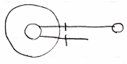

The line at the top is an actual connection.

The line at the bottom is the access conector.

#### Public Get Connection

A connection to an object, that required a Public Get access, looks like this:



The access connector stays visible, so that others can also connect to the object using Public Get.

#### Public Set Connection

A connection to an object, that required a Public Set access, looks like this:

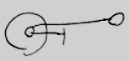

The access connector stays visible, so that others can also call Public Set and change the connection of the object.

#### Friend Connection

The general notation of a Friend connection is as follows:

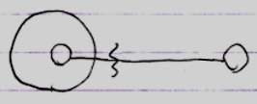

But remember that the *connector* always stays visible:

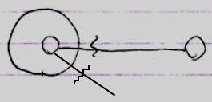

#### Friend Declaration, Connector and Connection

Here the difference is demonstrated between the notations of Friend declarations, Friend connectors and Friend connections. It will also become apparent how their notations disambiguate.

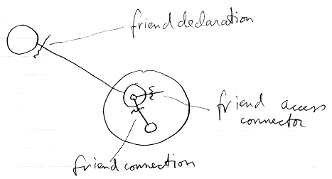

The friend *declaration* is always shown directly *near* the befriended (the situation at the top).

The friend access *connector* is always a loose end (the situation in the middle): one end of it is not connected yet. It is a placeholder for possible connections. A friend *connection* (the situation at the bottom) *is* connected at both ends. But the access symbol is placed in front the parent of the target symbol. This is because you always access an object through the parent symbol. The parent symbol can impose access restrictions onto its child objects.

If the friend connection would be an outward connection, no friend access mark would be displayed at all:

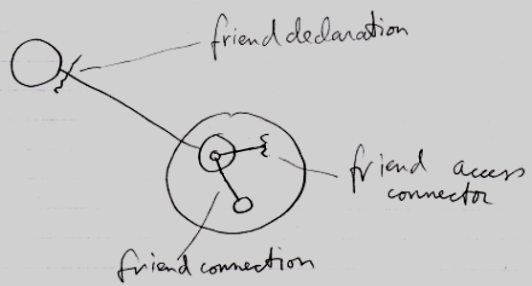

The friend connection shown there is not really a *friend* connection either. It is just a *connection*, an outward *connection*, a *passive* connection. What a releaf that a passive connection does not require an access symbol at all, or it would have conflicted with our friend declaration notation, which looks a bit like an outward connection with an access mark displayed in it, but it is not an access mark; it is a friend declaration.

#### Friend Get Connection

The picture below shows a Friend connection to Private Get:

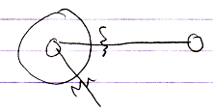

#### Friend Set Connection

The picture below shows a Friend connection, that required to Private Set access:

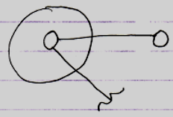

## Ideas

*The texts below are loose ideas, yet to be turned into good documentation.*

< Remembering, that the access connector stays visible has to be adressed in a single section and these explanations should not be bothered with that. >